Contemporary at Blue Star Celebrates 40 years of supporting contemporary art and artists!
The celebration includes a members-only exhibition tour, a family day, a brand-new mural by local artist Rubio, and the opening of new five new exhibitions featuring local artists.

40th Birthday Celebration: Saturday, June 27, 2026, from 10am–8pm | Learn More

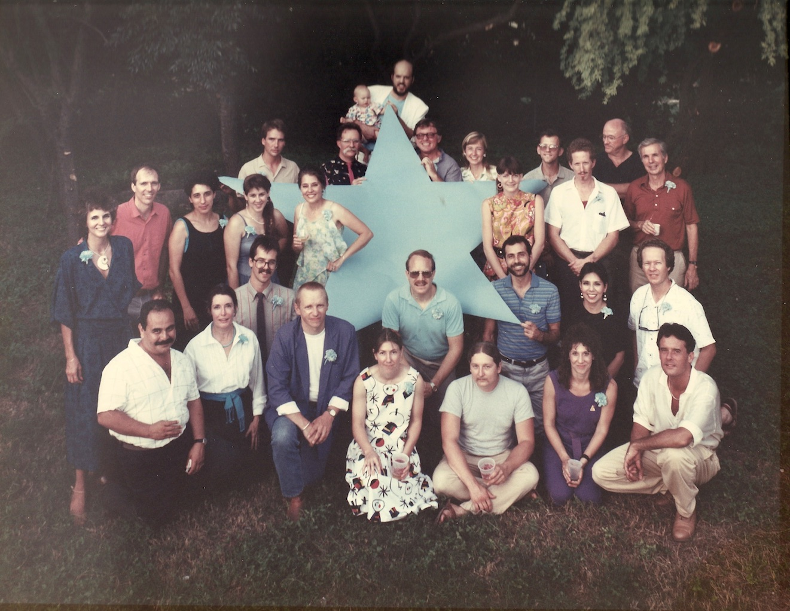

Blue Star Exhibition artists on June 27, 1986. Photo by Melanie Rush Davis.
Our Story
In June 1986 a group of San Antonio artists, driven by passion and vision, created what would become the city's first and longest-running nonprofit space for contemporary art in San Antonio. On June 27, 2026, the Contemporary will celebrate four remarkable decades of supporting artists of all ages in San Antonio with a daylong celebration that is free and open to our community.
The 40th anniversary is not just a milestone. It’s a testament to decades of bold vision, community engagement, and an unwavering commitment to nurturing artists through innovate contemporary art. From the spark of the Blue Star Exhibition in 1986, an exhibition that helped ignite San Antonio’s contemporary art scene, to becoming the city’s first W.A.G.E certified organization, the Contemporary has continued to emphasize what an artist-centric organization can be.
The Contemporary’s history is marked with continued innovation: launching Contemporary Art Month to celebrate contemporary throughout the city, investing in young artists through the MOSAIC Student Artist program, and providing international opportunity for artists through the prestigious Berlin Residency Program were major investments in not just the organization, but the people that make up our community. The Contemporary continues to surprise visitors, champion artists of all ages, and inspire the creative genius in us all.
The Birthday Schedule: Saturday, June 27, 2026
Members-Only Preview of our Summer Exhibitions, 10am–11am
Family Saturday | Happy Birthday to us, 1pm–4pm
Mural Dedication, 5pm–6pm
Exhibition Openings & Homecoming, 6pm–8pm
Since January, the Contemporary’s programs and exhibitions have been focused on a central pillar to the organization — "community"—a fitting tribute to the collaborative spirit that sparked its creation forty years ago. In keeping with this theme, the five new summer exhibitions feature artists that are connected to themes of legacy, community, and tradition, either through their practice or through their own involvement in the community. Featured artists include James Cobb, Bella Martinez, Soomin Jung Remmler, Mónica Martínez-Díaz, and Rubio.
About the Exhibitions
James Cobb was a featured artist in the Contemporary’s original Blue Star Exhibition in 1986. He is a painter and digital artist that molds the physical and the digital to create unique works that investigate current events and complex systems. This presentation of Cobb’s work will debut new paintings and recent digital works.
Emerging artist Bella Martinez is an alumna of our MOSAIC Student Artist Program, and she returns to the Contemporary with new and recent works. Like Cobb, Martinez is exploring the complexities of human interaction in the digital sphere. Creating first in a digital plane that transitions to the physical with everyday materials, Martinez reclaims her awareness of the here and now.
Artist Soomin Jung Remmler has a long history with the Contemporary through our Red Dot Art Sale. Primarily working in drawing and painting, Remmler creates vibrant scenes that capture her interest in the preciousness of special moments and memories. Experiencing her work is like walking through another realm, as she pulls from her own memories and the feelings and experience of reading a book and holding onto dreams.
A recent addition to San Antonio, Mónica Martínez-Dìaz’s photographic installation also spotlights the significance of memory, in this case how objects and memory blur the line between past and present. The fusion of experience, object, and memory hold the layers of identity, migration, and displacement and invites us to consider how identity is carried across borders. Mónica’s exhibition is made possible through the City of San Antonio’s Department of Arts and Culture Individual Artist Grant.
An alumnus of our Berlin Residency program (2023) and a former staff member of the Contemporary, Rubio returns with an exhibition that celebrates the rich culture of San Antonio’s Chicano community. The exhibition will feature a range of works, from his low rider series to American Folklore drawings.
The Contemporary also had the honor of working with Rubio to create a large-scale mural to celebrate our 40th anniversary milestone. The swirling, two-story mural spans the 171’ x 29’ façade of our San Antonio River-facing building, replacing our industrial-aesthetic gray and white exterior with a vibrant palette of blues reflecting the sky and river, highlighting our most beloved natural resources, supported in part by a Cultural District Grant from the Texas Commission on the Arts.
The Contemporary will continue celebrating through June 2027 with special programs, exhibitions, and highlights. The Contemporary has also launched a major gifts campaign, 400 for 40, to raise vital funds to sustain its mission. Additional information is available at contemporarysa.org/give or by contacting Development Director Elaine Leahy at (210) 343-1119 or elaine@contemporarysa.org.
###
Support
The Contemporary is grateful for the generous support from the City of San Antonio Department of Arts and Culture; Brown Foundation, Inc.; H-E-B, Kronkosky Charitable Foundation; Texas Commission on the Arts; the John L. Santikos Charitable Foundation, Beulah M. and Felix J. Katz Memorial Trust, M&M Keighley Fund, Ruth Lang Charitable Fund, E. B. Loch Charitable Fund, Dan and Gloria Oppenheimer Fund, Frances Margaret Seaver Fund, Valley View Trust, Becky "Beck" Whitehead Memorial Fund of the San Antonio Area Foundation. For ongoing support, we are incredibly appreciative of James Lifshutz and the Lifshutz Family, our Board of Directors and Advisory Council, and Contemporary Members and Donors. We are also thankful for the support of Guillermo Nicolás and Jim Foster Art Fund, Penelope Speier and Edward E. Collins, III, Rick Liberto & Ricos Products Co., Inc.; and Red Dot Artists, Collectors, and Sponsors.

About Contemporary at Blue Star

Contemporary at Blue Star presents exhibitions with artists from San Antonio and around the world sharing their global perspectives that encourage understanding, empathy, change, and action, fulfilling our mission to inspire, nurture, and innovate. Like most non-collecting contemporary art spaces, the Contemporary contributes fresh insights and perspectives on larger issues affecting society and culture by highlighting trends, movements, and conversations happening in art. Admission to the Contemporary is always free. Read our full story at contemporarysa.org/about.

